1) Develop Employee Management System for Litware Organization. Write a Class Library project LitwareLib.

a) Add class Employee with following private members:

❑ EmpNo int

❑ EmpName string

❑ Salary double

❑ HRA double

❑ TA double

❑ DA double

❑ PF double

❑ TDS double

❑ NetSalary double

❑ GrossSalary double.

Write methods for accepting EmpNo, EmpName and Salary. HRA, TA, DA, PPF, TDS, NET, GROSS should be calculated automatically. Follow the table for calculations.

Salary HRA % of Salary TA % of Salary DA % of Salary

<5000 10 5 15

<10000 15 10 20

<15000 20 15 25

<20000 25 20 30

>=20000 30 25 35

GrossSalary = Salary + HRA + TA + DA.

Calculate PF, TDS and Net salary in a function named “CalculateSalary()”

PF = 10 % of GrossSalary. TDS = 18 % of GrossSalary.

NetSalary = GrossSalary – (PF + TDS).

using System;

using System.Collections.Generic;

using System.Linq;

using System.Text;

class Program

{

class Employee

{

public string ID;

public string Name;

public double Salary;

public double HRA;

public double TA;

public double DA;

public double PF;

public double TDS;

public double NetSalary;

public double GrossSalary;

public void setDataEmployee(string ID, string Name, double Salary, double HRA, double TA, double DA, double PF, double TDS)

{

this.ID = ID;

this.Name = Name;

this.Salary = Salary;

//HRA – 20%, TA – 10%, DA – 50%, PF – 12%

this.HRA = HRA;

this.TA = TA;

this.DA = DA;

this.PF = PF;

this.TDS = TDS;

if (HRA < 0)

{

this.HRA = 20;

}

if (TA < 0)

{

this.HRA = 10;

}

if (DA < 0)

{

this.HRA = 50;

}

if (PF < 0)

{

this.HRA = 12;

}

this.GrossSalary = calculateGrossSalary();

this.NetSalary = calculateNetSalary();

}

public double calculateGrossSalary()

{

return Salary + Salary * HRA / 100.0 + Salary * TA / 100.0 + Salary * DA / 100.0;

}

public double calculateNetSalary()

{

return GrossSalary - (GrossSalary * PF / 100.0 + GrossSalary * TDS / 100.0);

}

}

class Library

{

private List<Employee> employees = new List<Employee>();

public void addEmployee(Employee emp)

{

this.employees.Add(emp);

}

public void displayEmployees()

{

for (int i = 0; i < employees.Count; i++)

{

Console.WriteLine("ID: {0}", employees[i].ID);

Console.WriteLine("Name: {0}", employees[i].Name);

Console.WriteLine("Salary: {0}", employees[i].Salary);

Console.WriteLine("HRA: {0}", employees[i].HRA);

Console.WriteLine("TA: {0}", employees[i].TA);

Console.WriteLine("DA: {0}", employees[i].DA);

Console.WriteLine("PF: {0}", employees[i].PF);

Console.WriteLine("TDS: {0}", employees[i].TDS);

Console.WriteLine("Net Salary: {0}", employees[i].NetSalary);

Console.WriteLine("Gross Salary: {0}", employees[i].GrossSalary);

Console.WriteLine();

}

}

}

static void Main(string[] args)

{

Library library = new Library();

int ch = -1;

do

{

Console.WriteLine("1. Register the employees in company");

Console.WriteLine("2. Display employee");

Console.WriteLine("3. Exit\n");

Console.Write("Your choice: ");

ch = int.Parse(Console.ReadLine());

if (ch == 1)

{

Console.Write("Enter Employee ID: ");

string ID = Console.ReadLine();

Console.Write("Enter Employee Name: ");

string Name = Console.ReadLine();

Console.Write("Enter Employee Salary: ");

double Salary = double.Parse(Console.ReadLine());

Console.Write("Enter Employee HRA (-1 skip): ");

double HRA = double.Parse(Console.ReadLine());

Console.Write("Enter Employee TA (-1 skip): ");

double TA = double.Parse(Console.ReadLine());

Console.Write("Enter Employee DA (-1 skip): ");

double DA = double.Parse(Console.ReadLine());

Console.Write("Enter Employee PF (-1 skip): ");

double PF = double.Parse(Console.ReadLine());

Console.Write("Enter Employee TDS: ");

double TDS = double.Parse(Console.ReadLine());

Employee emp = new Employee();

emp.setDataEmployee(ID, Name, Salary, HRA, TA, DA, PF, TDS);

library.addEmployee(emp);

}

else if (ch == 2)

{

library.displayEmployees();

}

else if (ch == 3)

{

}

} while (ch != 3);

Console.ReadKey();

}

}

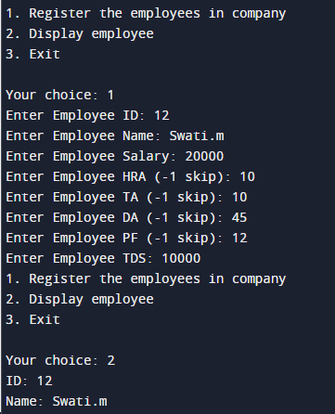

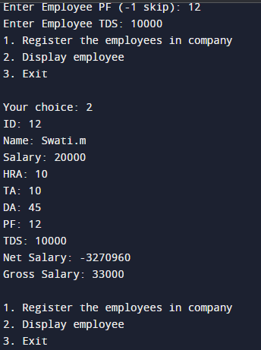

e. Write a console application Employee Management which allow HR staff member to register newly joined employee with EmpNo, EmpName and Salary. Display gross salary of employee on console. LitwareLib class Library will be used in Test console application for creating objects and invoking functionality of Employee class. Use Exception Handling mechanism wherever necessary.

using System;

using System.Collections.Generic;

using System.Linq;

using System.Text;

using System.Threading.Tasks;

namespace Litwarelib

{

class emp

{

private string emp_ID;

private string emp_name;

private double emp_sal;

public emp()

{

ID = emp_ID;

name = emp_name;

sal = emp_sal;

}

public string ID

{

get { return emp_ID; }

set { emp_ID = value; }

}

public string name

{

get { return emp_name; }

set { emp_name = value; }

}

public double sal

{

get { return emp_sal; }

set { emp_sal = value; }

}

public void display()

{

Console.WriteLine("Employee ID : "+ ID);

Console.WriteLine("Employee Name : " + name);

Console.WriteLine("Employee Salary : " + sal);

}

}

class Program

{

static void Main(string[] args)

{

emp[] e = new emp[3];

emp k = new emp();

for (int i = 1; i <= 3; i++)

{

Console.WriteLine("Enter Employee ID : ");

k.ID = Console.ReadLine();

Console.WriteLine("Enter Employee Name : ");

k.name = Console.ReadLine();

Console.WriteLine("Enter Employee Salary : ");

k.sal = Convert.ToDouble(Console.ReadLine());

Console.WriteLine("------------------------------------\n");

Console.WriteLine("Employee : " + i, "\n");

k.display();

Console.WriteLine("\n------------------------------------\n");

}

Console.ReadKey();

}

}

}

